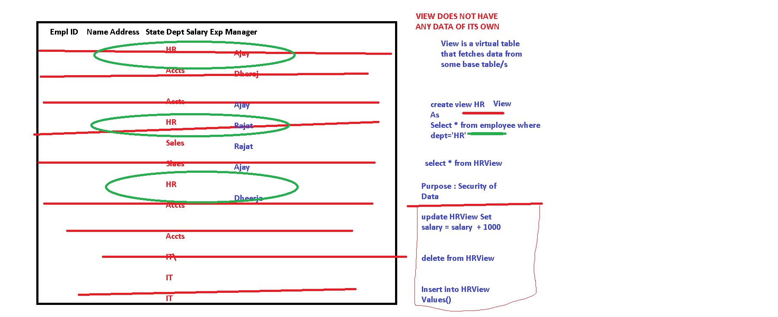

use practicedb

select \* from sys.tables

select \* from employee

create view DeptView

As

Select \* from employee where deptid=1

select \* from DeptView

insert into DeptView values(22,'Karan', 20000, 'N Delhi',

2,1)

alter view DeptView

As

Select \* from employee where deptid=1

WITH CHECK OPTION

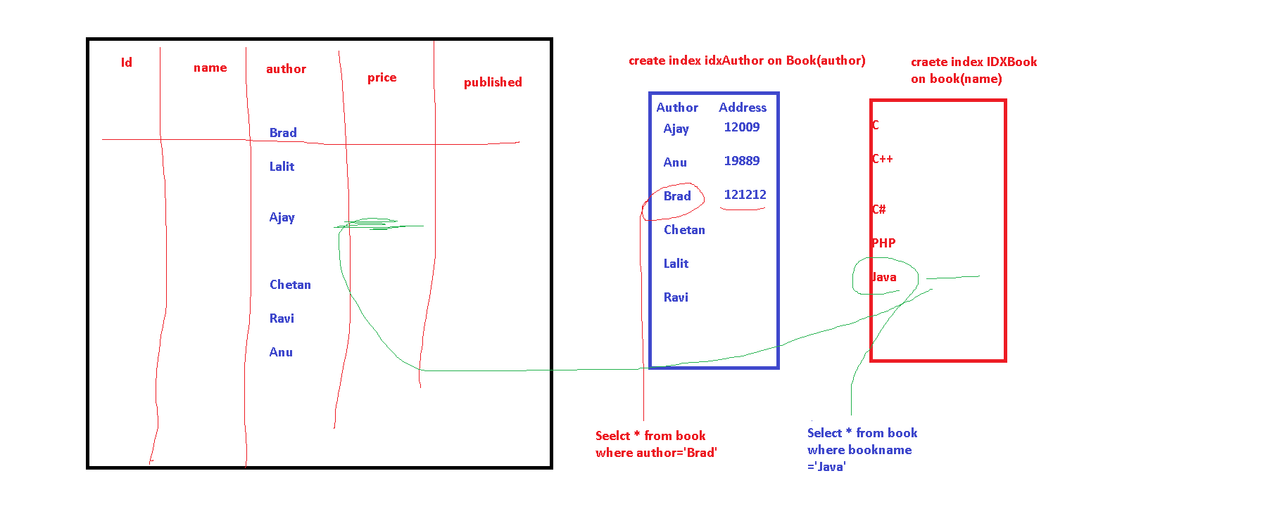

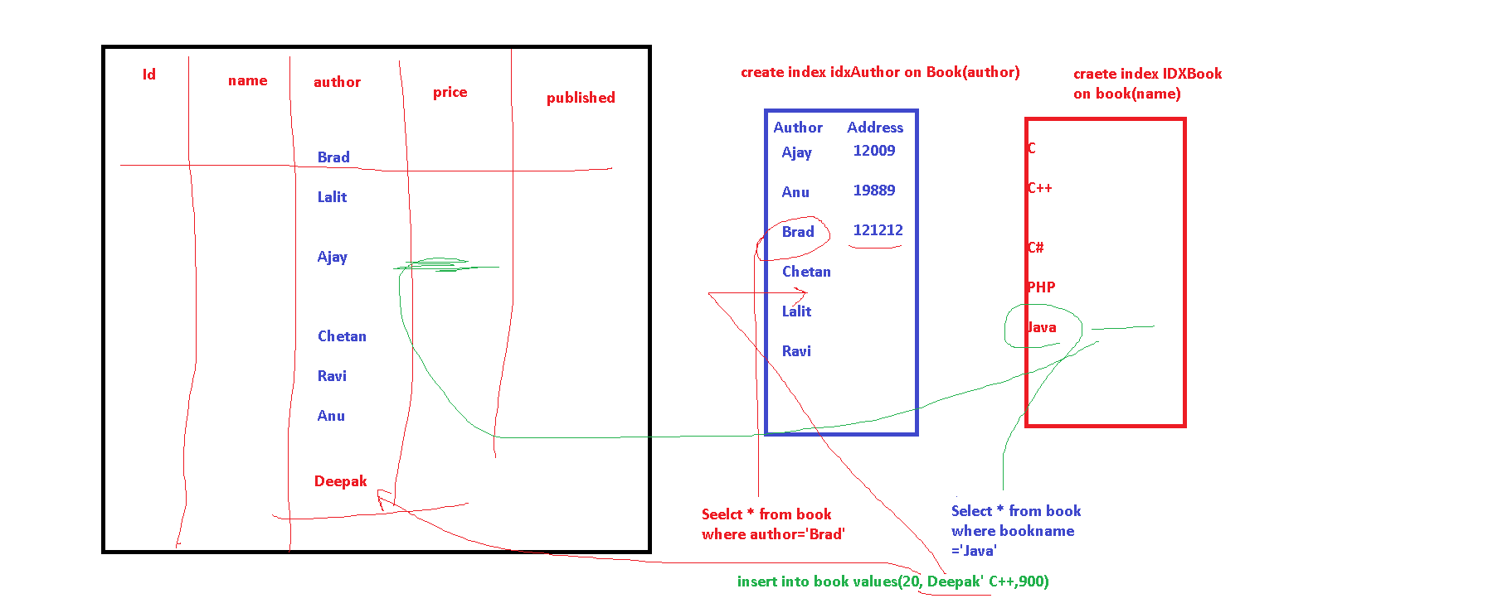

<https://www.c-sharpcorner.com/UploadFile/8af593/index-in-sql-server/>